Rhode Island

Test to Stay
Playbook - Barrington Public Schools

Updated: BPS December 13, 2021

Table of Contents

Table of Contents 2
Layered Mitigation Strategies with Test to Stay Program 3
Overview of Test to Stay 4
Eligibility 5
Testing 6
Testing Cadence 8
Quarantine Guidelines 11
Q & A 12
Glossary 14

Our focus is on ensuring a safe in-person learning environment with minimal disruptions, especially among those who have not had access to or have not yet been able to get fully vaccinated. Our goal is to keep students in school while keeping our communities safe.

Layered Mitigation Strategies with Test to Stay Program

The Rhode Island Department of Health (RIDOH) and the Rhode Island Department of Elementary and Secondary Education (RIDE) encourage schools to continue using the health and safety guidance provided in order to prevent outbreaks and to promote safe indoor practices throughout the Test to Stay Program.
- BPS will promote symptom screening for students and staff.
- Students will be seated at least three feet apart, at all times, and wear a mask, except at lunch.
- BPS understands that the Test to Stay Program is not an alternate protective measure to, or substitution for, vaccination.
- Symptomatic individuals cannot participate in the Test to Stay Program and will be sent home.
- Thorough contact tracing by the district COVID-19 team within 48 hours of the confirmed positive case, regardless of the number of close contacts and positive cases.
- BPS will provide the list of exposed students and staff to RIDOH when an individual gets a positive test result.
- BPS will continue to promote vaccinations for eligible students and staff.

Overview of Test to Stay

Students participating in Test to Stay may ride school transportation, attend all instructional activities at school, and participate in school-sponsored extracurricular activities, including athletics. Test to Stay is only available to those individuals who have been identified as close contacts due to exposure to COVID-19 in the school setting. It does not allow anyone who has tested positive to stay in school.

Test to Stay is only available to individuals who are not yet fully vaccinated; individuals who have not received any COVID-19 vaccination dose or have only received their first dose of the Moderna or Pfizer vaccine may participate.

Individuals who are participating in Test to Stay will not have to quarantine if they are identified as a close contact due to school exposure. If participating in Test to Stay, the individual must test negative on a rapid COVID-19 antigen test every day before proceeding to class. If the individual is participating in a school-sponsored activity on the weekend, the individual must test negative on a rapid COVID-19 antigen test before participating in the activity. The individual will participate in daily testing for a minimum of seven days from exposure. In the case that an individual participating in Test to Stay has a second close contact exposure during their initial Test to Stay testing period, the testing sequence must be restarted for the most recent close contact. The student should monitor for symptoms for 14 days following the last exposure.

Test to Stay does not change self-isolation requirements for those who have tested positive for COVID-19 and are within the infectious period.

If an individual participating in Test to Stay exhibits COVID-19 symptoms requiring self-isolation, the individual must self-isolate at home pending confirmation of a negative PCR test for COVID-19. If COVID-19 is confirmed, then self-isolation continues for 10 days following the day that symptoms began.

Eligibility

- Students in pre-kindergarten through 6th grade identified as a close contact due to a school exposure, who do not have COVID-19 symptoms, and who have consented to testing.  - Symptomatic students and staff must stay home, isolate, and get tested for COVID-19. Symptomatic individuals may not participate in Test to Stay.  - Test to Stay is only available to individuals who are not yet fully vaccinated; individuals who have not received any COVID-19 vaccination dose or have only received their first dose of the Moderna or Pfizer vaccine may participate. | Key Considerations  - Students in prekindergarten through 6th grade are recently eligible to receive COVID vaccinations, while older students have been eligible since May 2021. The best way to protect students against COVID-19 is vaccination; thus, schools should strongly promote vaccination amongst students as the primary strategy to reduce quarantines and keep students safe.  - Elementary school students identified as close contacts have been expected to quarantine at a very high rate (97%). Getting these students vaccinated will greatly reduce the number of missed school days due to quarantine.
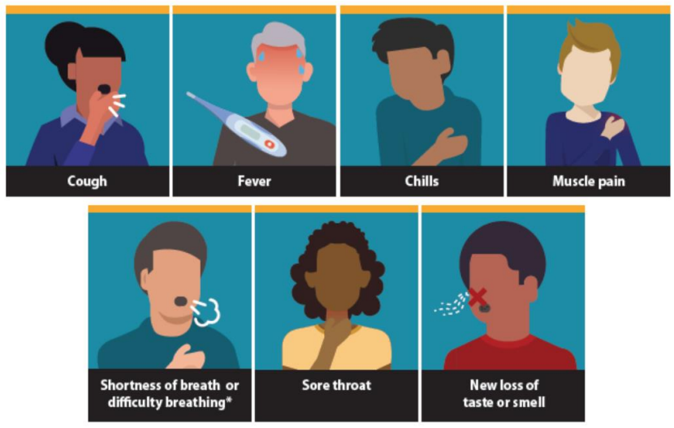
COVID-19 Symptoms
- Fever or chills;
- Cough (new);
- Shortness of breath or difficulty breathing;
- Fatigue;
- Muscle or body aches;
- Headache;
- Sore throat;
- New loss of taste or smell;
- Congestion or runny nose (new);
- Nausea or vomiting; or
- Diarrhea.

Testing

If not fully vaccinated, close contacts of COVID-19 infectious individuals have two options. The primary option is participation in a Test to Stay program. Individuals opting not to participate in Test to Stay must quarantine at home to help stop the spread of COVID-19, which is the secondary option.  - Students who choose to participate in the Test to Stay program must be tested at school (on school days) for quick and easy verification.  - Weekend testing is required for students when participating in school activities over the weekend. Weekend testing will either be administered at school sites or via home testing.  - Students identified as a close contact who are participating in the Test to Stay program must quarantine when at home and cannot attend non-related school activities. | Key Considerations  - Weekend testing: In order to safely support students who participate in extracurricular activities, participants of the program must follow the same protocol as when attending school: 1) get tested before participating in an activity or attending a class during the weekend and 2) wear a mask indoors. (There must be adult supervision to ensure mask-wearing.)  - It is recommended schools consider having tests on hand to conduct PCR testing when students or staff become symptomatic to expedite results and case identification.

Visual Testing Examples

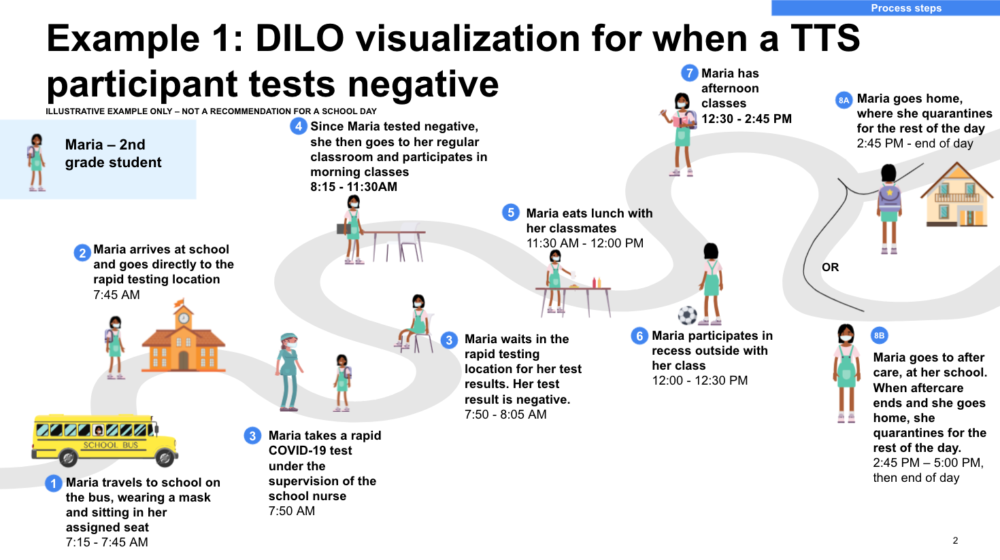
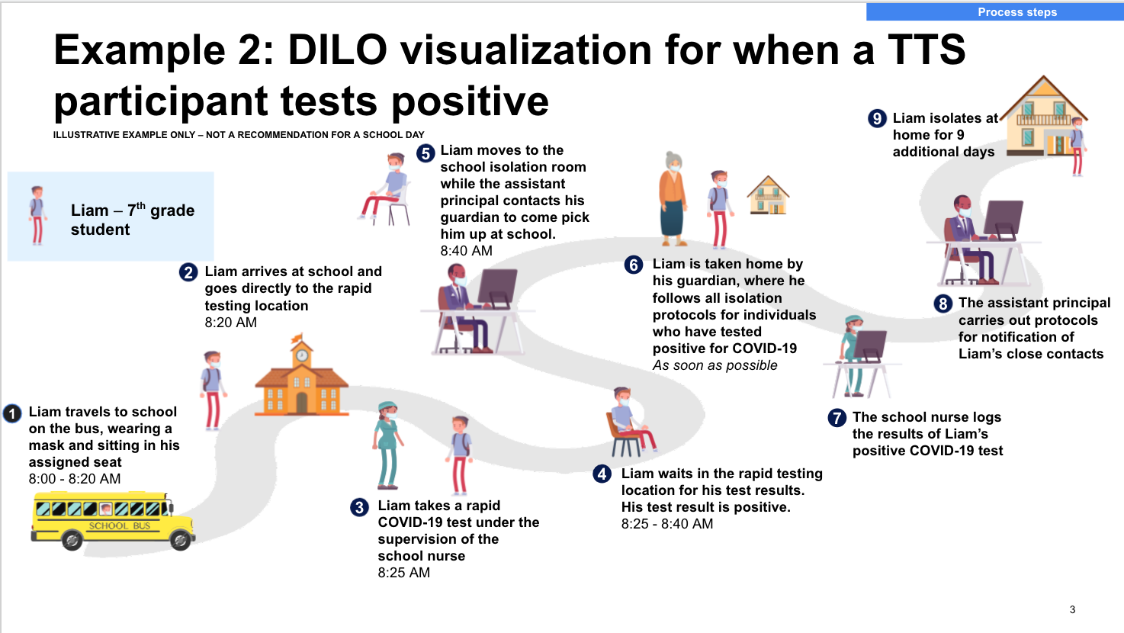

Testing Cadence

- A rapid antigen test will be administered at the start of the school day for up to seven days from the date of exposure.  - If the seventh day of quarantine falls on the weekend or on a holiday, the student is required to get tested the next day at school. | Key Considerations  Seven-day antigen testing is required:  - Serial testing with rapid antigen tests results in the likelihood of a higher Positive Predictive Value (PPV) than one-time testing.  - Daily testing is easier to implement, and it is easier to track students who require tests.

Testing Cadence Examples
Example 1: Testing begins on Tuesday, no participation in weekend extracurriculars
Scenario: An individual began showing symptoms on Monday, and received a positive result on their PCR test that same day. Their close contacts are identified and notified, and those who opt-in begin participating in the Test to Stay program on Tuesday.

Below is an example of a student who will receive a rapid test when they arrive at school on Tuesday through Friday and the following Monday. S/he does not participate in any school extracurricular activities on the weekend, so s/he will quarantine at home when the student’s school day ends and for the two weekend days. His/her last day of rapid testing will be on Monday, assuming all tests are negative, and no other student or staff test positive during the testing period. The student will continue to monitor for symptoms for a full 14 days from last exposure.

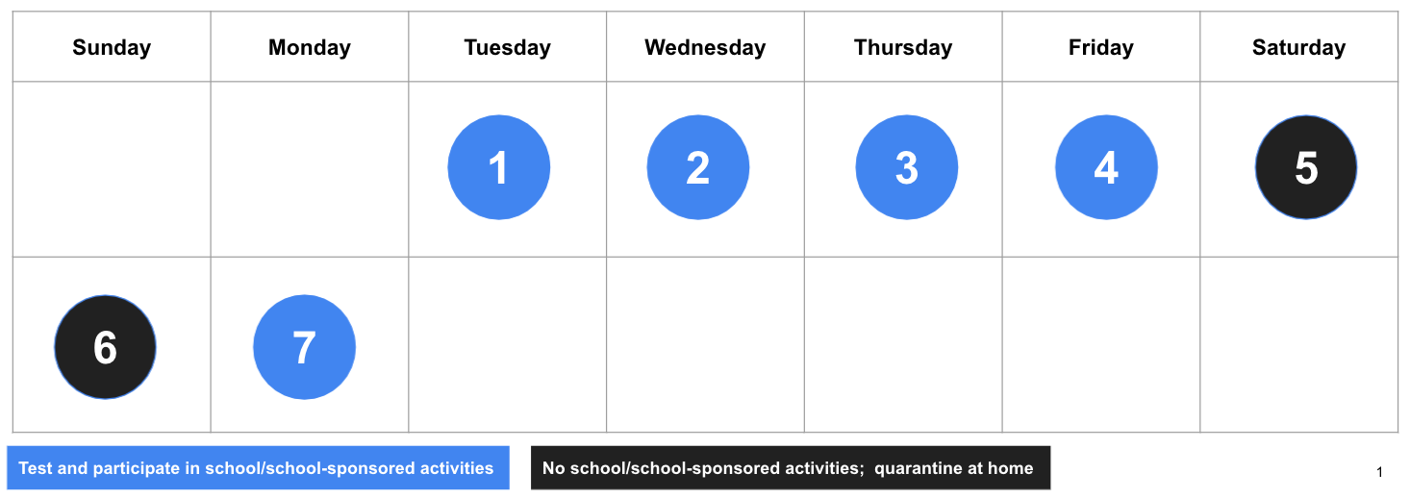
Example 2: Testing begins on Tuesday, with a long weekend and no participation in extracurriculars
Scenario: An individual began showing symptoms on Monday, and receives a positive result on their PCR test that same day. Their close contacts are identified and notified, and those who opt in begin participating in the Test to Stay program on Tuesday.

Below is an example of a student who will receive a rapid test when they arrive at school on Tuesday through Friday and the following Tuesday. S/he does not participate in any school extracurricular activities on the weekend and there is no school on Monday, so s/he will quarantine at home when the student’s school day ends and at home for those 3 days. His/her last day of rapid testing will be the following Tuesday, assuming all tests are negative and no other students or staff are identified during the testing period. The student will continue to monitor for symptoms for a full 14 days from last exposure.

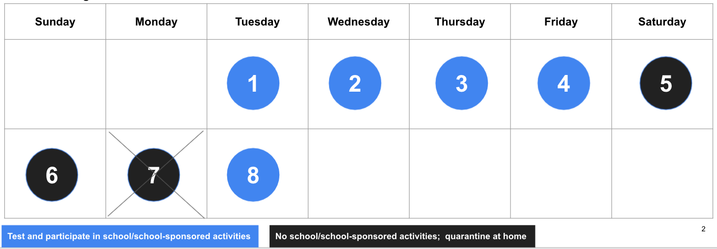
Example 3: Testing begins on Friday, and student participates in weekend extracurriculars
Scenario: An individual began showing symptoms on Tuesday, and receives a positive result on their PCR test on Thursday. Their close contacts are identified and notified, and those who opt in begin participating in the Test to Stay program on Friday.

Below is an example of a student who will receive a rapid test when they arrive at school on Friday, on Saturday before his/her sports practice, and the following Monday through Thursday. S/he does not participate in any school extracurricular activities on the Sunday, so s/he will quarantine at home for that day. His/her last day of rapid testing will be on Thursday, assuming all tests are negative. The student must quarantine when not participating in school related activities and monitor for symptoms for the 14 days from the last exposure.

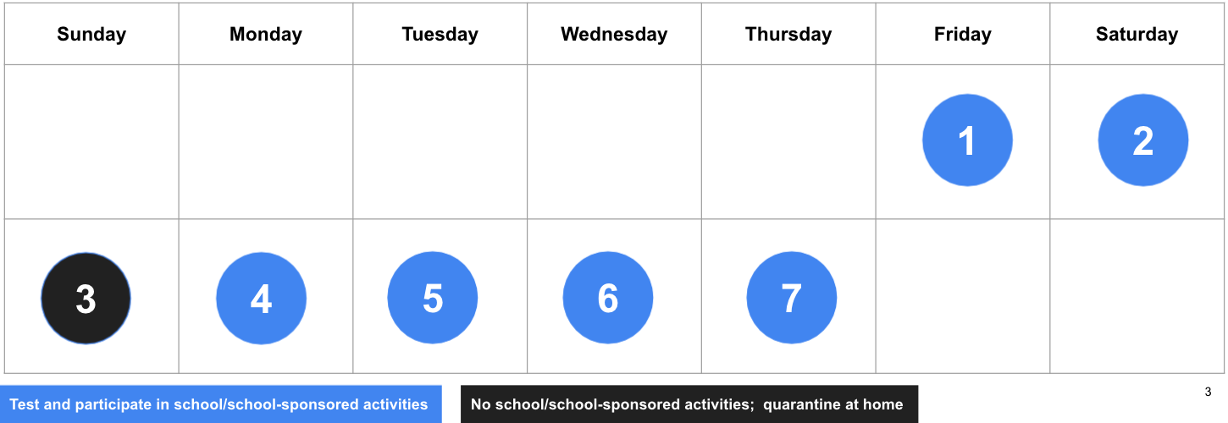
Example 4: Student is identified as a close contact again, while still during initial testing period
Scenario: an individual began showing symptoms on Tuesday, and receives a positive result on their PRC test that same day. Their close contacts are identified and notified, and those who opt in begin participating in the Test to Stay program on Wednesday. The student began testing daily via Test to Stay on Wednesday. S/he does not participate in any school extracurricular activities on the Sunday, so s/he will quarantine at home for that day.

Though the student’s last day of testing would have been on Tuesday, s/he was identified as a close contact of a second positive case and was exposed on Friday but was not aware until Monday. Because s/he was a close contact a second time and exposed on Friday, s/he would participate in testing through the following Friday.

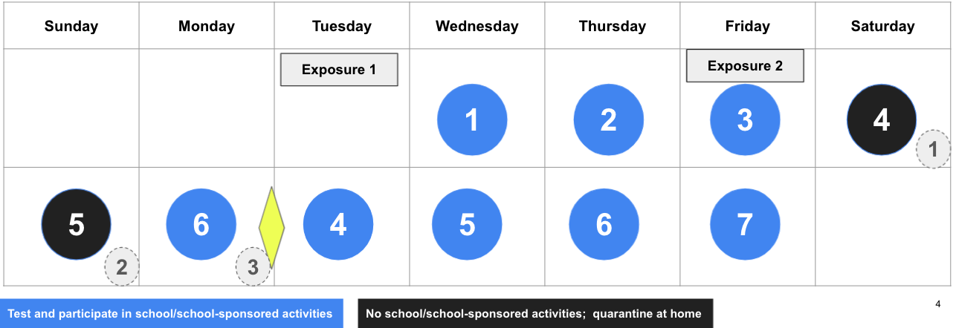

Quarantine Guidelines

Students who choose to participate in the Test to Stay program:  - May attend school and school-related extracurricular activities where there is adult supervision to ensure mask-wearing;  - May take the school bus to and from school;  - May attend before and after-school care that is sponsored or regulated by RIDE where there is adult supervision to ensure mask-wearing;  - May not attend non-school-related activities (e.g., Girl Scouts, club sports, etc.); and  - Must abide by quarantine guidelines outside of school.  Individuals who are exempt from quarantine should not participate in TTS. Exemptions to quarantine are:  - People with documented COVID-19 infection in the last 90 days;  - Fully vaccinated individuals;  - Those who meet the PreK-12 Close Contact Quarantine Exception criteria;  - PreK-12 students or staff and the exposure happened during outdoor recess at school; or  - Were exposed on a PreK-12 school bus when windows were open, everyone wore face masks, and both the driver and at least one additional adult were present to confirm proper mask use and open windows. | Key Considerations  - Close contact is in quarantine when not at school: The student is still at risk of testing positive, and attending non-school related activities is a risk for community transmission.  - School-run transportation  - School-run transportation is a key support for some children to be able to attend school and is an equity issue.  - All riders on the bus must continuously wear a face mask and windows should be open.  - Participation in school-related extracurricular activities only  - School-related extracurricular activities have, and enforce, layered mitigation strategies which help to minimize risk of spreading to the community.  - The purpose of this initiative is to enable children to attend school and reduce education gaps.  - Attendance at in-district/in-school childcare only.  - There are some complexities involved in operationalizing the use of facilities that are not run by schools as they must be notified by RIDOH.

PreK-12 Student Close Contact Exception
A PreK-12 student exposed to another PreK-12 student infected with COVID-19 doesn’t need to quarantine if all of the following are true:
- Both the infected person and exposed close contact are Pre K-12 students;
- The exposure occurred in an indoor Pre K-12 classroom or structured outdoor pre K-12 setting where mask use can be observed;
- Both the exposed close contact student and the infected student wore face masks at all times during the close contact exposure; and
- At least three feet of physical distance was maintained at all times during the exposure.

Q & A

- How is this different from the way that students can already test out of quarantine?
According to Executive Order 21-105, students who don’t have symptoms can shorten the quarantine period to 7 days (from 10) if they get a negative result from a lab-processed PCR test taken at least 5 days after the exposure. In this case, the person would be required to stay home for 7 days, returning to school and activities on the eighth day.

- If parents/guardians have already given consent for surveillance testing, are districts required to obtain new consent for students' participation in Test to Stay?
Yes, parents/guardians must provide consent specifically to Test to Stay, as it is not the same program nor testing frequency as other testing that may already be conducted at the school.

- Must all students in PreK through 6th grade participate in Test to Stay?
No, the TTS program is available for districts to implement in PreK through 6th grade, but it is at the discretion of the implementing district regarding which of these grade levels they will make TTS available for, given school configurations and staffing availability. Additionally, only students who are unvaccinated and/or partially vaccinated may participate in TTS.

- If a student is notified that they’re a close contact during the school day, do they need to get tested that same day?
No. If students are notified that they’re close contacts during a school day, they will begin their seven days of antigen testing on the next school day. If initial notification occurs on a Friday, and the students have a school-related event over the weekend, they’ll either be sent home with tests to administer over the weekend or be tested on-site before their weekend school event.

- Can students participating in TTS take the bus to school?
Yes. Students participating in TTS are permitted to use school-run transportation. Students must wear a mask and sit in their assigned seat while riding the bus.

- Can students participate in extracurricular activities when in TTS?
Students who remain asymptomatic and test negative may attend school-related extracurricular activities. However, they must continue to follow quarantine guidelines outside of school and shall not attend non-school related activities during their quarantine period

- Can students get tested outside of school for TTS?
No. Students must be tested at school to participate in TTS.

- What if a student in TTS starts having symptoms of COVID-19?
Any student who isn’t feeling well must follow existing school sick policies and stay home until they’ve completed the testing and isolation requirements for symptoms of COVID-19.

- If the school is participating in TTS, can we go back to the way things were before COVID-19?
No. The purpose of TTS is to ensure that students can attend in-person learning as much as possible. This program reduces the number of instructional days missed because it allows students to remain at school, as long as they do not have symptoms of COVID-19, and get negative test results every day during their seven-day quarantine period. TTS is not a substitute for other safety and mitigation practices used in schools. To ensure student and staff safety, we will still need to ensure proper mask-wearing and distancing, screen for symptoms daily, keep students in cohorts, improve ventilation, maintain seating charts, and track student movement throughout the building for contact tracing purposes.

- What if students participating in TTS are late to school?
School staff are responsible for ensuring that students participating in TTS and identified as close contacts get tested before proceeding to class. If a student is late to school, the school must have a process for verifying their participation in TTS upon arrival and ensuring they get tested.

- What happens if a student is absent and misses one of their days of testing?
Only asymptomatic students are eligible to participate in TTS. If a student is asymptomatic and is absent from school, they will continue daily testing when they return to school the following day.
If a student is symptomatic and is absent from school due to this reason, they should stay home, isolate, and get tested for COVID-19. They may not resume participation in TTS if they are absent due to symptoms.

Glossary

Close contact: Being within six feet of an infected person (with or without a face mask) for a total of 15 minutes, in a 24-hour period or having unprotected direct contact with secretions or excretions of a person with confirmed COVID-19 during the infectious period in either an indoor or outdoor setting.

Confirmed case: A person who has tested positive for SARS-CoV-2 infection (the virus that causes COVID-19).

Contact tracing: Process of identifying individuals who have had close contact (see definition above) with someone infected with COVID-19.

COVID-19: Abbreviation for the disease caused by the novel coronavirus SARS CoV-2.

Infectious period: Time during which an infected person is contagious and most likely to spread sears to others.
- ​​Infectious period for asymptomatic cases: Two days prior to testing (the date of the swabbing was conducted) until CDC criteria to discontinue isolation are met.
- Infectious period for symptomatic cases: Two days before symptom onset until CDC criteria to discontinue isolation are met.

Isolation: The process of separating someone who is sick or who tested positive for COVID-19 away from others by staying home from school, work, and/or other activities while infectious. Isolation lasts a minimum of:
- 10 days from symptom onset if symptomatic.
- 10 days from the date of specimen collection (test) is asymptomatic.
- 20 days for individuals with severely immunocompromising conditions.

Quarantine: Process of separating and restricting the movement of individuals who were in close contact with someone who tested positive or had symptoms of COVID-19. Persons in quarantine should self-monitor for 14 days for symptoms and seek medical advice as needed. RIDOH recommends all close contacts of people with COVID-19 get tested on day 5 of quarantine or later.

RIDE: Rhode Island Department of Education

RIDOH: Rhode Island Department of Health

Symptomatic individual: A person who is experiencing one or more of the symptoms of COVID-19 as defined in CDC guidelines.

Testing: Three types of tests are available to detect COVID-19: viral tests, antigen tests, and antibody tests.
- Viral tests and antigen tests indicate if you have a current infection For viral tests there are two types: molecular tests, often referred to as PCR tests, and antigen tests
- Antibody tests indicate a previous infection.

